-

DATA-EFFICIENT URDU SPEECH CORPUS CONSTRUCTION

MANAL ASGHAR & (FA24-MSDS-0004)



COMPUTER SCIENCE

FACULTY OF COMPUTING

MOHAMMAD ALI JINNAH UNIVERSITY

FALL 2026

DATA-EFFICIENT URDU SPEECH CORPUS CONSTRUCTION

SUBMITTED BY
MANAL ASGHAR & (F24-MSDS-0004)

SUPERVISED BY
DR. TAFSEER AHMED



THESIS SUBMITTED TO THE [TYPE NAME
OF THE FACULTY (for example FACULTY OF COMPUTING)],
MOHAMMAD ALI JINNAH UNIVERSITY, IN PARTIAL FULFILMENT OF
THE REQUIREMENTS FOR THE DEGREE OF [TYPE NAME OF THE DEGREE HERE
IN FULL FORM (for example MASTER OF SCIENCE IN COMPUTER
SCIENCE)]

FALL 2026

Certificate of Approval


It is certified that the research work presented in this thesis, titled Data-efficient Urdu speech corpus construction was conducted by Manal Asghar under the supervision of Dr. Tafseer Ahmed].
No part of this thesis has been submitted anywhere else for any other degree.
This thesis is submitted to the Department of Computer Science in partial fulfilment of the requirements for the degree of
Masters of Science in Fall 2025 at the
Mohammad Ali Jinnah University
Karachi, Pakistan
[Place Date of Thesis Defense here (for example Month DD, YYYY)]

Name of Candidate: _________________________ Signature: ______________
Examination Committee Members:
- Name of External Examiner: _______________ Signature: ________________
Designation, Affiliation:

- Name of Internal Examiner: ________________ Signature: ________________
Designation, Affiliation:

- Name of Supervisor: ______________________ Signature:
________________
Designation, Affiliation:
________________________________________
Name :
Dean, (Name of the Faculty) [for example (Faculty of
Computing)] Mohammad Ali Jinnah University, Karachi

Certificate of SUPERVISION


This is to certify that the thesis titled, “Data-efficient Urdu speech corpus construction”, is submitted to the Department of Computer Science,Fall 2025 by Manal Asghar for the award of the degree of Master of Science in the discipline of Computer Science Data-science AI. The thesis has been carried out under my supervision. I certify that the work submitted is original and not plagiarized from any other source, except as specified in the references. Neither the thesis nor the work contained therein has been previously submitted to any other institution for a degree.

_____________________________
Dr. Tafseer Ahmed

MOHAMMAD ALI JINNAH UNIVERSITY

ORIGINAL LITERARY WORK DECLARATION

Faculty | Faculty of Computing
Program | MS Data Science
Student Name: Manal Asghar |  | Reg. No: FA24-MSDS-0004
Email: FA24MSDS0004@maju.edu.pk |  | Mobile No:0316-8036790

Research Title: Data-efficient Urdu speech corpus construction

I do solemnly and sincerely declare that:
- I am the author of this work.
- This work is original.
- Use of any work in which copyright exists was done by way of fair dealing and for permitted purposes and any excerpt or extract from, or reference to or reproduction of any copyright work has been disclosed expressly and sufficiently and the title of the Work and its authorship have been acknowledged in this Work; I do not have any actual knowledge nor do I ought reasonably to know that the making of this work constitutes an infringement of any copyright work.

- I hereby assign all and every rights in the copyright to this work to Mohammad Ali Jinnah University (MAJU), who henceforth shall be owner of the copyright in this Work and that any reproduction or use in any form or by any means whatsoever is prohibited without the written consent of MAJU having been first had and obtained.

- I am fully aware that if in the course of making this work I have infringed any copyright whether intentionally or otherwise, I may be subject to legal action or any other action as may be determined by MAJU.

Student’s Signature: ______________________ Place: Karachi-Pakistan.

Acknowledgements
I would like to express my sincere gratitude to my supervisor, Dr. Tafseer Ahmed, for his unwavering support, guidance, and encouragement throughout this research. His invaluable insights and patience have been instrumental in shaping this thesis.
I also appreciate Mohammad Ali Jinnah University and the Department of Computer Science for providing the necessary resources and a conducive learning environment that enabled me to complete this study.
A heartfelt thanks to my friends and classmates for their motivation, insightful discussions, and continuous support throughout this journey. Their encouragement has been a source of strength for me.
Finally, I am profoundly grateful to my family for their unconditional love, patience, and constant encouragement. Their support has been my greatest source of motivation.
This thesis would not have been possible without the contributions and support of these incredible individuals.
Thank you!

Abstract
The development of Automatic Speech Recognition (ASR) and Text-to-Speech (TTS) systems for low-resource languages is largely constrained by the limited availability of high-quality and representative speech corpora. Although large Urdu text corpora are available, recording speech for every sentence is expensive, time-consuming, and impractical. Therefore, selecting a small yet representative subset of text before speech recording is essential for reducing corpus construction cost while preserving the linguistic characteristics of the original dataset.
This research proposes a data-efficient framework for representative Urdu speech corpus construction through distribution-aware text subset selection. A large Urdu corpus containing approximately 5.7 million sentences was first converted into a unified International Phonetic Alphabet (IPA) representation to ensure language-independent phonetic processing. Instead of performing word-level analysis, the proposed framework represents each sentence using character-level IPA unigrams and bigrams, enabling the selection process to capture both phonetic diversity and contextual relationships among phonetic units.
Two greedy-based subset selection algorithms were investigated. The first algorithm employs a character coverage–based greedy selection strategy with a priority queue to iteratively select sentences that maximize the introduction of previously uncovered IPA characters and character pairs. The second algorithm introduces a deficit-driven greedy selection strategy that prioritizes under-represented IPA units by continuously minimizing the distributional deficit between the selected subset and the complete corpus. Due to the computational complexity of exact deficit-driven selection over the complete corpus, the second algorithm was implemented and executed on a GPU-enabled computing environment.
The quality of the generated subsets was evaluated using intrinsic statistical measures, including Type Coverage, Token Probability Coverage, and Kullback–Leibler (KL) Divergence, computed over both unigram and bigram distributions. Furthermore, the proposed algorithms were compared against random sampling using identical subset sizes of 0.1%, 1%, 5%, 10%, 15%, and 20% of the original corpus. The experimental results demonstrate that the proposed greedy-based approaches achieve substantially higher phonetic coverage while maintaining close distributional similarity with the original corpus. In particular, the deficit-driven greedy strategy produces representative subsets that preserve important phonetic and contextual information using only a small fraction of the complete dataset.
The proposed framework provides an efficient methodology for constructing representative Urdu speech corpora while significantly reducing the amount of text required for speech recording. The methodology is scalable to very large corpora and can be adapted to other low-resource languages that require cost-effective speech corpus development.
Keywords: Urdu Speech Corpus, Low-Resource Languages, Automatic Speech Recognition, Text-to-Speech, Representative Subset Selection, Greedy Algorithm, Deficit-Driven Selection, Character-Level IPA, Unigram, Bigram, KL Divergence, Type Coverage, Token Probability Coverage.

Table of Contents

CHAPTER 1: INTRODUCTION ................................................................. 1
1.1 Discussion on Urdu Speech Technology ................................................. 1
1.1.1 Resource Constraints in Urdu Speech Data ........................................ 1
1.1.2 Importance of Text Selection Prior to Speech Recording ................. 2
1.2 Discussion on Data-Efficient Corpus Construction ............................... 2
1.3 Text Subset Selection for Speech Corpus Design .................................. 3
1.4 Distribution-Aware Greedy Selection and Its Benefits ........................ 4
1.5 Evaluation of Text Subset Representativeness ...................................... 5
1.6 Problem Statement ................................................................................. 6
1.7 Research Aim and Objectives ................................................................. 7
1.8 Significance of the Study ...................................................................... 8

CHAPTER 2: LITERATURE REVIEW ..................................................... 10
2.1 Speech Corpus Construction ................................................................. 10
2.2 Data-Efficient Text Selection ............................................................... 13
2.3 Greedy Algorithms for Subset Selection .............................................. 16
2.4 Distribution-Aware Selection Methods ................................................. 18
2.5 Random Sampling Approaches ............................................................. 20
2.6 Evaluation Metrics in Corpus Selection ............................................... 22
2.7 Research Gap ........................................................................................ 24

CHAPTER 3: PROPOSED METHODOLOGY .......................................... 26
3.1 Research Framework ............................................................................ 26
3.2 Dataset Description .............................................................................. 27
3.3 IPA Conversion .................................................................................... 29
3.4 Character-Level Text Representation ................................................... 31
3.4.1 Character-Level IPA Unigrams ........................................................ 31
3.4.2 Character-Level IPA Bigrams .......................................................... 32
3.5 Algorithm 1: Greedy Character Coverage-Based Selection ................. 34
3.6 Algorithm 2: Deficit-Driven Greedy Selection ..................................... 39
3.7 Random Baseline ................................................................................. 44
3.8 Evaluation Methods ............................................................................. 45
3.8.1 Type Coverage ................................................................................. 45
3.8.2 Token Probability Coverage ............................................................ 46
3.8.3 KL Divergence ................................................................................ 47
3.8.4 Unigram Evaluation ......................................................................... 48
3.8.5 Bigram Evaluation ........................................................................... 48

CHAPTER 4: RESULTS AND DISCUSSION ........................................... 50
4.1 Experimental Setup ............................................................................. 50
4.2 Algorithm 1 Results ............................................................................ 52
4.3 Algorithm 2 Results ............................................................................ 56
4.4 Random Baseline Results .................................................................... 60
4.5 Comparative Analysis .......................................................................... 63
4.6 Discussion ............................................................................................ 68

CHAPTER 5: CONCLUSION AND FUTURE WORK ............................... 72
5.1 Conclusion ........................................................................................... 72
5.2 Contributions of the Study .................................................................. 73
5.3 Limitations .......................................................................................... 74
5.4 Future Work ........................................................................................ 75

References .................................................................................................. 77
Plagiarism Verification (For Final Submission)
Plagiarism Report
List of Tables List of Figures

Figure 1 : Abc ………………………………………………………………………………. 00

List of Abbreviations
TTS | Text To Speech
ASR | Automatic Speech Recognition
KL Divergence | Kullback–Leibler Divergence
LRL | Low-Resource Language

Data-efficient Urdu speech corpus construction

Manal Asghar

Mohammad Ali Jinnah University

Author Note
Department of [Computer Science], 22-E, Block-6, P.E.C.H.S., Lal Kothi Stop, Main Shahrah-e-Faisal, Karachi, 75400, Sindh, Pakistan.
Email ID: FA24MSDS0004@maju.edu.pk

CHAPTER 1

INTRODUCTION
Automatic Speech Recognition (ASR) and Text-to-Speech (TTS) systems have shown significant improvements in recent years because of advances in machine learning and the availability of large speech datasets. However, these developments mainly benefit high-resource languages, while low-resource languages such as Urdu still face many challenges due to the lack of large and representative speech corpora.
Although a large amount of Urdu text is available from books, newspapers, websites, and other digital sources, converting all of this text into speech is not practical. Speech corpus construction requires speaker recruitment, recording, verification, and annotation, which makes the process expensive and time-consuming. Therefore, selecting a small but representative subset of text before recording is an important step in building an efficient speech corpus.
Most existing approaches use either random sampling or manually selected sentences. These methods are simple but often fail to preserve the linguistic characteristics of the original corpus. As a result, the selected data may not provide sufficient phonetic and contextual coverage for training robust ASR and TTS systems.
This research focuses on developing a data-efficient approach for Urdu speech corpus construction. A large Urdu corpus containing approximately 5.7 million sentences is used as the source dataset. The complete corpus is first converted into International Phonetic Alphabet (IPA) representation. Instead of using word-level features, the proposed approach represents each sentence using character-level IPA unigrams and bigrams to capture both phonetic diversity and contextual relationships.
Two greedy-based subset selection algorithms are investigated in this study. The first algorithm selects sentences based on character coverage, while the second algorithm uses a deficit-driven strategy to prioritize under-represented IPA units. The quality of the selected subsets is evaluated using Type Coverage, Token Probability Coverage, and KL Divergence. In addition, the proposed methods are compared with random sampling using different subset sizes to determine their effectiveness.
The proposed methodology aims to generate representative subsets that preserve the statistical characteristics of the original corpus while significantly reducing the amount of text required for speech recording. This can help reduce the overall cost of speech corpus construction and support the future development of Urdu speech technologies.

1.1 Discussion on Urdu Speech Technology
Urdu is one of the major languages spoken in South Asia and is the national language of Pakistan. Millions of people use Urdu in their daily communication, education, literature, and digital media. Although the language has a rich linguistic and literary background, its development in modern speech technologies is still limited compared to high-resource languages such as English and Chinese.
Recent advances in artificial intelligence have significantly improved speech recognition and speech synthesis systems. These systems require large amounts of high-quality speech data for training. However, Urdu lacks large publicly available speech corpora that can support the development of accurate ASR and TTS systems. Most of the available datasets are either small, domain-specific, or collected for a particular research purpose, making them unsuitable for large-scale speech applications.
The availability of a representative speech corpus is one of the key requirements for developing reliable speech technologies. A representative corpus should capture the phonetic and contextual diversity of the language so that speech models can generalize well to unseen data. Therefore, efficient speech corpus construction has become an important research area for low-resource languages such as Urdu.

1.1.1 Resource Constraints in Urdu Speech Data
The major challenge in Urdu speech technology is the shortage of high-quality speech datasets. Unlike high-resource languages, Urdu has limited speech resources that are freely available for research purposes. Collecting speech data requires selecting suitable text, recording speakers, validating recordings, and preparing annotations. Each of these steps requires considerable time, cost, and human effort.
Although large Urdu text corpora are available, recording every sentence is practically impossible. For example, a corpus containing millions of sentences would require thousands of hours of speech recordings, making the process expensive and difficult to manage. As a result, researchers need methods that can identify only the most informative and representative sentences for recording.

1.1.2 Importance of Text Selection Prior to Speech Recording
The quality of a speech corpus depends not only on the number of recorded sentences but also on the quality of the selected text. If the selected sentences do not represent the overall characteristics of the language, the resulting speech corpus may contain unnecessary repetition while missing important phonetic patterns.
Selecting representative text before speech recording helps reduce recording cost while maintaining the linguistic diversity of the original corpus. Instead of recording millions of sentences, a carefully selected subset can preserve most of the important information required for training speech models. This makes text subset selection an essential step in data-efficient speech corpus construction.

1.2 Discussion on Data-Efficient Corpus Construction
Data-efficient corpus construction is a research area that focuses on selecting informative and representative data instead of increasing the overall size of the dataset. In speech technology, collecting and annotating speech data requires considerable time, cost, and human effort. Therefore, it is important to use available resources efficiently by selecting only those sentences that contribute the most to the linguistic diversity of the corpus.
Traditional speech corpus construction often relies on collecting a large amount of speech data with the expectation that more data will produce better results. However, this approach is not always practical for low-resource languages because recording and annotating millions of sentences is both expensive and time-consuming. In such situations, selecting a smaller but representative subset becomes a more suitable solution.
The main objective of data-efficient corpus construction is to preserve the important statistical characteristics of the original corpus while significantly reducing the amount of data that needs to be recorded. A representative subset should contain sufficient phonetic and contextual diversity so that speech recognition and speech synthesis systems trained on it can still perform effectively. As a result, data-efficient corpus construction reduces both the financial cost and the time required for speech corpus development without sacrificing linguistic quality.

1.3 Text Subset Selection for Speech Corpus Design
Text subset selection is the process of selecting a limited number of sentences from a very large text corpus while preserving the linguistic characteristics of the complete dataset. This step plays an important role in speech corpus construction because only the selected sentences will later be recorded by speakers.
A well-designed subset should represent the phonetic, lexical, and contextual properties of the original corpus. If the selected sentences contain only frequently occurring patterns, many important language units may remain uncovered. On the other hand, selecting sentences completely at random may include unnecessary repetitions and may not guarantee sufficient linguistic diversity.
In this research, the subset selection process is performed on the phonetic representation of the corpus rather than the original Urdu script. The complete corpus is first converted into International Phonetic Alphabet (IPA) representation, after which each sentence is represented using character-level IPA unigrams and bigrams. This representation allows the selection algorithms to consider both individual phonetic units and their contextual relationships during the selection process.
The selected subsets are generated for different corpus sizes, including 0.1%, 1%, 5%, 10%, 15%, and 20% of the complete corpus. These subsets are later evaluated to determine how well they preserve the statistical characteristics of the original dataset.

1.4 Distribution-Aware Greedy Selection and Its Benefits
Selecting representative sentences from a corpus containing millions of sentences requires an efficient selection strategy. Greedy algorithms provide a practical solution because they build the subset incrementally by selecting one sentence at a time according to a predefined scoring function.
Unlike random sampling, distribution-aware greedy algorithms attempt to preserve the statistical distribution of the original corpus throughout the selection process. At each iteration, the algorithm selects the sentence that contributes the greatest improvement according to the selected criterion. This enables the subset to gradually become more representative of the complete dataset.
In this research, two greedy-based selection algorithms are investigated. The first algorithm focuses on maximizing character-level IPA unigram and bigram coverage by selecting sentences that introduce the largest number of previously uncovered phonetic units. The second algorithm follows a deficit-driven strategy, where sentences containing under-represented IPA units are given higher priority. This approach continuously updates the distributional deficit after each selected sentence, allowing the subset distribution to move closer to the distribution of the complete corpus.
The use of greedy algorithms provides several advantages. First, they eliminate unnecessary duplicate information by selecting informative sentences. Second, they improve the phonetic and contextual coverage of the selected subset. Finally, they provide a scalable solution that can be applied to very large text corpora without requiring exhaustive search over all possible sentence combinations.

1.5 Evaluation of Text Subset Representativeness
Selecting a subset from a large corpus is only useful if the selected data can effectively represent the characteristics of the original corpus. Therefore, it is necessary to evaluate the quality of the generated subsets using suitable statistical measures. The evaluation process helps determine whether the selected subset preserves the linguistic information of the complete dataset.
In this research, the generated subsets are evaluated using intrinsic evaluation metrics instead of training an ASR or TTS model. This approach allows the quality of different subset selection algorithms to be compared directly without the influence of model architecture or training parameters. The evaluation is performed using Type Coverage, Token Probability Coverage, and Kullback–Leibler (KL) Divergence. These metrics are calculated for both character-level IPA unigrams and bigrams.
Type Coverage measures how many unique IPA units present in the complete corpus are also present in the selected subset. Token Probability Coverage measures how much of the original corpus probability distribution is covered by the selected subset. KL Divergence measures the difference between the probability distributions of the original corpus and the selected subset. Lower KL Divergence indicates that the selected subset is more representative of the original corpus. In addition to evaluating the proposed greedy algorithms, the same evaluation metrics are also applied to randomly selected subsets for comparison.

1.6 Problem Statement
Large Urdu text corpora are available from various digital sources; however, converting the complete corpus into speech is not feasible because of the high cost and time required for recording and annotation. Recording millions of sentences is beyond the available resources of most research projects, making efficient sentence selection an essential step in speech corpus construction.
Existing approaches often rely on random sampling or manually selected sentences, which may not preserve the statistical characteristics of the complete corpus. As a result, the generated speech corpus may contain unnecessary repetition while failing to represent important phonetic and contextual patterns of the language.
This research addresses this problem by developing distribution-aware greedy algorithms that can automatically select representative subsets from a large Urdu corpus. The objective is to generate smaller subsets that closely preserve the statistical properties of the original corpus while significantly reducing the amount of speech data that needs to be recorded.

1.7 Research Aim and Objectives
The main aim of this research is to develop a data-efficient framework for constructing a representative Urdu speech corpus by selecting informative text subsets from a large corpus using greedy-based selection algorithms.
The objectives of this research are as follows:
- To analyze the statistical characteristics of a large Urdu text corpus after converting it into IPA representation.
- To represent each sentence using character-level IPA unigrams and bigrams for phonetic analysis.
- To implement a character coverage-based greedy algorithm for representative subset selection.
- To implement a deficit-driven greedy algorithm that reduces the distributional difference between the selected subset and the complete corpus.
- To compare the performance of the proposed algorithms with random sampling using different subset sizes.
- To evaluate the generated subsets using Type Coverage, Token Probability Coverage, and KL Divergence.

1.8 Significance of the Study
The proposed research contributes to Urdu speech technology by providing a practical framework for constructing representative speech corpora using a small fraction of the original text corpus. Instead of focusing on collecting a large amount of speech data, the study emphasizes selecting informative and representative sentences before the recording process.
The proposed methodology can reduce the overall cost and effort required for speech corpus construction while preserving important phonetic and contextual information. This makes the framework useful for academic research as well as organizations working on Urdu ASR and TTS systems.
Although this research is conducted on Urdu, the proposed methodology is not limited to a single language. Since the selection process is based on character-level IPA representation and statistical distributions, the same approach can be applied to other low-resource languages with minor modifications. Therefore, the proposed framework has the potential to support future speech corpus construction for several under-resourced languages.

CHAPTER 2:

LITERATURE REVIEW
Speech technologies such as Automatic Speech Recognition (ASR) and Text-to-Speech (TTS) require suitable speech data for training and evaluation. The collection of speech data is usually a difficult task, particularly for languages where large speech resources are not easily available. Recording speakers, checking the recorded audio, and preparing the related text require both time and resources [1], [17].
For this reason, researchers have studied different ways of selecting useful data from large datasets. The purpose of data selection is to use a smaller amount of data while keeping the important properties of the original dataset. This chapter discusses previous studies related to speech corpus development, text selection, greedy algorithms, distribution-based selection, and phonetic representation.

2.1 Speech Corpus Construction
A speech corpus is an important part of ASR and TTS development. It normally contains recorded speech and the corresponding textual information. The design of the corpus can affect the quality of a speech system because the recorded data should contain sufficient linguistic and phonetic variation [7], [17].
For Urdu, the availability of large speech datasets is still limited compared with high-resource languages. Raza et al. developed a phonetically rich Urdu speech corpus and focused on the importance of phonetic coverage during corpus design [7]. Their study showed that the choice of recording sentences is important because a corpus should contain different sound patterns of the language.
Urdu speech recognition has also been evaluated in recent studies. Arif et al. examined different Urdu ASR models and discussed the challenges related to Urdu speech resources [16]. In speech synthesis, Naseem et al. studied Punjabi and Urdu TTS using multilingual transfer learning [22].
These studies show that speech data quality is an important issue for Urdu speech technology. Therefore, the selection of suitable text before recording may help in building a more useful speech corpus.

2.2 Data-Efficient Text Selection
Data-efficient selection is based on the idea that using the complete dataset is not always necessary. A smaller subset may contain enough useful information for a particular task if the samples are selected carefully.
Azeemi et al. reviewed different speech data selection methods and discussed how useful samples can be selected when annotation and computational resources are limited [17]. The study highlights the importance of data selection in reducing the amount of data required for speech processing.
Subset selection has also been applied in ASR. Kothawade et al. proposed DITTO for targeted subset selection in accent adaptation [5]. Rangappa et al. selected speech data for ASR fine-tuning using domain classification and pseudo-label filtering [19]. Zheng et al. used active learning to identify useful speech samples and reduce labeling requirements [20].
Although these methods are designed for different speech tasks, they follow a similar concept. Instead of using all available samples, an informative subset is selected. The same general idea is used in this research for Urdu text selection before speech recording.

2.3 Greedy Algorithms for Subset Selection
Greedy selection is a simple approach in which samples are selected one by one. At each stage, the algorithm chooses the sample that provides the highest current benefit according to the scoring function.
Greedy methods are useful when the number of possible sample combinations is very large. Testing every possible subset is not practical for a large dataset. Therefore, greedy selection provides a more manageable way of constructing a subset.
Das and Khetan presented DEFT-UCS, an unsupervised core-set selection method for data-efficient fine-tuning [21]. The method demonstrates how a smaller set of samples can be selected from a larger collection.
Seki et al. studied data selection for TTS through an evaluation-in-the-loop approach [2]. Their work uses repeated evaluation during the data selection process. TTSOps also introduced an iterative corpus optimization process for TTS training data [23].
These studies show that informed and iterative selection can be useful for large datasets. In the present research, greedy selection is applied to character-level IPA features extracted from Urdu text.

2.4 Distribution-Aware Selection
Feature coverage is important, but it does not completely describe the quality of a subset. A subset may contain a particular feature but its frequency may be very different from the frequency found in the complete corpus.
For example, a rare feature may appear once in the selected subset and therefore be counted as covered. However, the overall feature distribution of the subset may still be different from the original data.
Previous studies have considered diversity and distribution during subset construction. Maekawa et al. proposed DiLM for text-level dataset distillation [3]. The study explored the representation of a larger dataset using a smaller amount of data.
Seki et al. used linguistic and acoustic information for diversity-based core-set selection in TTS [18]. TTSOps also used a closed-loop process to improve the selected corpus during TTS training [23].
These approaches indicate that sample selection should consider more than simple feature presence. Based on this idea, the second algorithm in this research considers the difference between the IPA feature distribution of the selected subset and the complete corpus.

2.5 Character-Level and Phonetic Representation
The representation of text is an important part of the selection process. Word-level representation can produce a large vocabulary, particularly when a corpus contains millions of sentences. Many words may occur only a small number of times, which can increase data sparsity.
Speech corpus construction is closely related to pronunciation. Therefore, phonetic information can provide a more suitable representation for sentence selection. The importance of phonetic richness in Urdu corpus development was discussed by Raza et al. [7].
Research on low-resource TTS has also considered pronunciation-related information and speech-oriented representations. ALIGN2SPEAK used ASR-guided optimization for low-resource TTS [24]. Naseem et al. investigated multilingual transfer learning for Punjabi and Urdu speech synthesis [22].
In this research, Urdu text is represented using the International Phonetic Alphabet (IPA). The IPA text is processed at the character level. Individual IPA characters are treated as unigrams, while two adjacent IPA characters are treated as bigrams.
The use of character-level features reduces the size of the feature space compared with word-level representation. Bigrams also provide information about adjacent character patterns, which is not available from individual unigrams alone.

2.6 Representative Subset Selection for Speech Data
The purpose of representative subset selection is to obtain a smaller dataset that keeps useful characteristics of the original data. Different selection strategies have been used in ASR and TTS research.
DITTO used targeted data selection for ASR accent adaptation [5]. Diversity-based core-set selection was studied for TTS using linguistic and acoustic features [18]. Domain classification and pseudo-label filtering have also been applied for selecting ASR fine-tuning data [19].
Active learning provides another method for reducing data requirements. Zheng et al. selected useful samples for ASR labeling through an unsupervised active learning approach [20].
However, many of these methods work with speech data that has already been recorded. Some methods require acoustic features, model predictions, confidence values, or pseudo-labels [18], [19], [20].
The present research considers a different stage of corpus development. The selection process is performed on text before speech recording. Therefore, reducing the number of selected sentences may directly reduce the amount of text that needs to be recorded.

2.7 Evaluation of Selected Subsets
A selected subset should be compared with the complete corpus to determine how much information has been retained. Different studies on data selection have considered coverage, diversity, and distribution when evaluating selected data [17], [18].
In this research, three evaluation measures are used. The first measure is Type Coverage. It calculates how many unique IPA unigram or bigram types from the complete corpus are available in the selected subset. A higher Type Coverage value means that more feature types have been retained.
The second measure is Token Probability Coverage. This metric considers the probability mass of the full corpus represented by the features found in the selected subset. It provides additional information beyond the number of unique feature types.
The third measure is KL Divergence. It is used to compare the probability distribution of the selected subset with the distribution of the complete corpus. A lower KL Divergence value indicates a smaller difference between the two distributions.
The metrics are calculated separately for character-level IPA unigrams and bigrams. Unigram evaluation focuses on individual IPA characters, whereas bigram evaluation considers adjacent IPA character pairs.

2.8 Research Gap
Previous research has studied data selection for ASR adaptation, TTS training, active learning, and core-set construction [5], [18], [19], [20], [21]. Urdu speech research has also considered phonetic corpus design, ASR evaluation, and low-resource speech synthesis [7], [16], [22].
However, a large part of the existing data selection research works with speech data after recording. Acoustic information, trained models, confidence scores, or speech labels may be required during selection [18], [19], [20].
There is limited work on selecting Urdu text before speech recording by directly using character-level IPA unigram and bigram information. The use of greedy and distribution-aware strategies for this particular text selection problem also requires further investigation.
This research addresses this gap by selecting representative sentences from a large IPA-converted Urdu text corpus. Two selection algorithms are used to generate subsets at different sizes. The selected subsets are then evaluated using Type Coverage, Token Probability Coverage, and KL Divergence and compared with random sampling.

2.9 Chapter Summary
This chapter discussed previous studies related to speech corpus construction and data selection. Existing research shows that informed subset selection can reduce data requirements in different ASR and TTS tasks [17], [18], [23].
The literature also indicates that many selection methods are applied after speech data has already been collected. In comparison, this research performs character-level IPA-based text selection before speech recording.
The next chapter explains the dataset preparation, feature extraction, proposed selection algorithms, and evaluation methodology used in this research.

next chapter.

CHAPTER 3

PROPOSED METHODOLOGY

3.1 Overview
This chapter presents the methodology adopted for constructing a representative Urdu speech corpus from a large text corpus. The proposed framework aims to select a smaller subset of sentences that preserves the statistical characteristics of the complete corpus while reducing the amount of text required for speech recording.
The methodology consists of several stages, including dataset preparation, IPA conversion, feature extraction, representative subset selection, and evaluation. First, the complete Urdu corpus is converted into International Phonetic Alphabet (IPA) representation. Each sentence is then represented using character-level IPA unigrams and bigrams. These features are used by the proposed greedy-based algorithms to generate representative subsets. Finally, the quality of the generated subsets is evaluated using statistical evaluation metrics.

3.2 Dataset Description
The experiments were conducted using a large Urdu text corpus consisting of approximately 5.7 million sentences. The corpus contains text collected from multiple sources and represents a wide variety of writing styles and vocabulary. Since the objective of this research is to construct a representative speech corpus, the complete dataset was considered as the reference corpus from which smaller representative subsets were generated.
Processing millions of sentences directly requires considerable computational resources. Therefore, efficient data structures and preprocessing techniques were used to reduce memory usage and improve the overall execution speed of the proposed algorithms.

3.3 IPA Conversion
Before subset selection, the complete Urdu corpus was converted into the International Phonetic Alphabet (IPA) representation. IPA provides a standardized phonetic representation in which every symbol corresponds to a particular speech sound. Using IPA reduces the dependence on Urdu orthography and allows the selection algorithms to operate on phonetic information instead of written words.
After conversion, unnecessary spaces were removed while preserving the sequence of IPA characters. This converted corpus served as the input for feature extraction and representative subset selection.

3.4 Character-Level Text Representation
Instead of using words as basic linguistic units, this research represents each sentence using character-level IPA units. This representation simplifies the feature space while preserving phonetic information.
Character-level representation also enables the algorithms to identify frequently occurring and under-represented phonetic patterns more effectively than word-level processing, particularly for a very large corpus.

3.4.1 Character-Level IPA Unigrams
A character-level unigram represents a single IPA character occurring in a sentence. The complete corpus was analyzed to determine the frequency distribution of all unique IPA characters. These unigram statistics were later used during subset selection and evaluation.

3.4.2 Character-Level IPA Bigrams
A character-level bigram consists of two consecutive IPA characters. Unlike unigrams, bigrams capture contextual phonetic information because they preserve the relationship between adjacent characters. The frequency distribution of all unique IPA bigrams was computed for the complete corpus and used by both proposed algorithms during sentence selection.

3.5 Feature Extraction
After converting the corpus into IPA representation, character-level features were extracted from every sentence. Two types of features were used in this research: character-level IPA unigrams and character-level IPA bigrams.
Each sentence was processed individually. All unique IPA characters present in the sentence were extracted to generate the unigram feature set. Similarly, all consecutive pairs of IPA characters were extracted to generate the bigram feature set. These features were stored in an efficient format so that they could be accessed quickly during the subset selection process.
In addition, the frequency distribution of all IPA unigrams and bigrams was computed for the complete corpus. These distributions were later used by both proposed algorithms during sentence selection and by the evaluation metrics to measure how closely the selected subsets represented the original corpus.

3.6 Algorithm 1: Greedy Character Coverage-Based Selection
The first proposed method is a greedy-based subset selection algorithm that aims to maximize the coverage of character-level IPA unigrams and bigrams. Instead of selecting sentences randomly, the algorithm iteratively chooses the sentence that contributes the largest number of previously uncovered IPA characters and character pairs.
Initially, the selected subset is empty, and no unigram or bigram is marked as covered. During each iteration, every candidate sentence is assigned a score based on the number of new IPA unigrams and bigrams it can introduce into the selected subset. The sentence with the highest score is selected and added to the subset. After selection, the covered unigram and bigram sets are updated before the next iteration begins.
To improve computational efficiency, a priority queue was used to organize candidate sentences according to their scores. Instead of recomputing scores for all sentences after every selection, only the most promising candidate was re-evaluated before selection. This Lazy Greedy strategy significantly reduced computation while producing the same final subset as the standard greedy approach.
The algorithm continued until the required subset size was reached. Representative subsets containing 0.1%, 1%, 5%, 10%, 15%, and 20% of the complete corpus were generated using this approach.

Algorithm 1 Lazy Greedy Selection
Input:
Corpus C
Target size n

Output:
Representative subset S

1. Compute feature representation for every sentence.
2. Initialize S ← ∅.
3. Build a priority queue using initial sentence scores.
4. while |S| < n do
5. Remove highest-scoring sentence s.
6. Recompute Score(s).
7. if Score(s) remains highest then
8. S ← S ∪ {s}
9. Update feature coverage.
10. else
11. Reinsert s into priority queue.
12. end if
13. end while
14. return S

3.7 Algorithm 2: Deficit-Driven Greedy Selection
The second proposed method focuses on preserving the statistical distribution of the complete corpus. Instead of maximizing only feature coverage, this algorithm prioritizes IPA units that are under-represented in the currently selected subset.
The algorithm first computes the probability distributions of character-level IPA unigrams and bigrams for the complete corpus. During subset selection, the difference between the complete corpus distribution and the selected subset distribution is calculated for every IPA unit. This difference is referred to as the distributional deficit.
At each iteration, every candidate sentence receives a score based on the remaining deficits of the IPA unigrams and bigrams contained in that sentence. The sentence with the highest score is selected because it contributes the greatest reduction in the overall distributional deficit. After selection, the unigram and bigram distributions of the selected subset are updated, and new deficit values are computed before the next iteration.
Since this algorithm performs exact score computation over the complete corpus at every iteration, the computational cost is significantly higher than Algorithm 1. Therefore, the implementation was executed on an AWS EC2 GPU virtual machine using GPU-accelerated sparse matrix operations. The generated subsets were later evaluated using the same evaluation metrics as Algorithm 1.

Algorithm 2
Input:
- Corpus CCC
- Target subset size nnn
Output:
- Representative subset SSS
Algorithm 2: Deficit-Driven Greedy Core-Set Selection

1. Initialize S ← ∅

2. Compute the full corpus unigram probability distribution
Puni.

3. Compute the full corpus bigram probability distribution
Pbi.

4. Initialize the selected unigram counts to zero.

5. Initialize the selected bigram counts to zero.

6. while |S| < n do

7. Compute the remaining unigram deficit

δuni = max(0, Puni − Pselected_uni)

8. Compute the remaining bigram deficit

δbi = max(0, Pbi − Pselected_bi)

9. For every candidate sentence s ∈ C − S, compute

Score(s) =
α × Σ δuni(u)
+
β × Σ δbi(b)

10. Select the sentence having the maximum score.

11. Add the selected sentence to S.

12. Update the selected unigram counts.

13. Update the selected bigram counts.

14. end while

15. return S

3.8 Random Baseline
To evaluate the effectiveness of the proposed methods, a random sampling baseline was also implemented. For each target subset size, sentences were selected randomly from the complete corpus without considering character coverage or statistical distribution.
The random subsets contained the same number of sentences as the subsets generated by the proposed algorithms. Their quality was evaluated using the same evaluation metrics, allowing a fair comparison between random sampling and the proposed greedy-based approaches.

3.9 Evaluation Methods
After generating representative subsets using the proposed algorithms, their quality was evaluated by comparing them with the complete corpus. The purpose of the evaluation was to determine how well the selected subsets preserved the statistical characteristics of the original dataset. The same evaluation procedure was applied to all subset sizes generated by both proposed algorithms as well as the random baseline.
The evaluation was performed on character-level IPA unigrams and bigrams because these features were used during the subset selection process. Three evaluation metrics were used in this research: Type Coverage, Token Probability Coverage, and Kullback-Leibler (KL) Divergence.

3.9.1 Type Coverage
Type Coverage measures the proportion of unique IPA units present in the selected subset compared with the complete corpus. A higher Type Coverage indicates that the selected subset contains a larger number of unique IPA characters or character pairs from the original corpus.
The Type Coverage is calculated as:
Type Coverage= Type_Coverage = |V_subset ∩ V_full| / |V_full|
where,
VsubsetV_{subset}Vsubset​ represents the set of unique IPA units in the selected subset, and
VfullV_{full}Vfull​ represents the set of unique IPA units in the complete corpus.
A value closer to 1 indicates better coverage of the original corpus.

3.9.2 Token Probability Coverage
Token Probability Coverage measures how much probability mass of the complete corpus is preserved in the selected subset. Unlike Type Coverage, this metric considers the occurrence frequency of IPA units instead of only their presence.
It is calculated as
Token_Probability_Coverage = sum of P_full(w) for all words w in V_subset

where Pfull(w)P_{full}(w)Pfull​(w) represents the probability of an IPA unigram or bigram in the complete corpus.
Higher Token Probability Coverage indicates that the selected subset preserves a larger portion of the statistical distribution of the complete dataset.

3.9.3 Kullback-Leibler (KL) Divergence
KL Divergence measures the difference between the probability distribution of the complete corpus and that of the selected subset. It is one of the most widely used statistical measures for comparing probability distributions.
The KL Divergence is calculated as
D_KL(P_full || P_subset)
= sum of [ P_full(w) × log( P_full(w) / P_subset(w) ) ]
where
Pfull(w)P_{full}(w)Pfull​(w) is the probability of an IPA unit in the complete corpus, and
Psubset(w)P_{subset}(w)Psubset​(w) is the probability of the same IPA unit in the selected subset.
Laplace smoothing was applied during probability estimation to avoid zero-probability values.
A lower KL Divergence indicates that the selected subset is statistically closer to the original corpus. Therefore, among the evaluation metrics used in this research, KL Divergence is considered the primary measure for assessing the representativeness of the generated subsets.

3.10 Experimental Setup
All experiments were performed on a complete Urdu corpus containing approximately 5.7 million sentences. The corpus was first converted into IPA representation, after which character-level unigram and bigram features were extracted for every sentence.
Representative subsets of 0.1%, 1%, 5%, 10%, 15%, and 20% of the complete corpus were generated using both proposed algorithms. For comparison, random subsets of the same sizes were also generated.
Algorithm 1 was implemented using a Lazy Greedy strategy with a priority queue to reduce computational cost while maintaining selection quality. Algorithm 2 employed an exact deficit-driven greedy strategy that computed sentence scores at every iteration. Due to the computational requirements of exact score computation over the complete corpus, Algorithm 2 was executed on an AWS EC2 GPU virtual machine.
The generated subsets were evaluated using the three evaluation metrics described above. The evaluation was performed separately for character-level IPA unigrams and bigrams to analyze both phonetic coverage and contextual coverage.

CHAPTER 4
RESULTS AND DISCUSSION

4.1 Introduction
This chapter presents the experimental results of the proposed Urdu text subset selection framework. The complete IPA-converted corpus was first analyzed using character-level unigram and bigram frequencies. The selected subsets generated by Algorithm 1, Algorithm 2, and random sampling were then evaluated using Type Coverage, Token Probability Coverage, and KL Divergence. The results are reported for subset sizes ranging from 0.1% to 20% of the complete corpus. This chapter also compares the three selection approaches and discusses their effectiveness in preserving the statistical characteristics of the original dataset.
4.2 Character-Level IPA Frequency Analysis
Research Objective 1 focuses on analyzing the statistical characteristics of the Urdu corpus after IPA conversion. Therefore, the frequencies of character-level IPA unigrams and bigrams were calculated before applying the subset selection algorithms.
4.2.1 Top Character-Level IPA Unigrams
The complete corpus contained 78 unique character-level IPA symbols. Table 4.1 presents the ten most frequent unigram characters.
Table 4.1: Top 10 Character-Level IPA Unigrams

Rank | Unigram | Frequency
1 | A | 31073739
2 | r | 21286374
3 | a | 21001650
4 | E | 20672585
5 | k | 19877929
6 | h | 18101422
7 | n | 17544074
8 | m | 14675639
9 | t | 12468014
10 | s | 12168204

The results show that A was the most frequent IPA character, with more than 31 million occurrences. It was followed by r, a, and E. The frequency gradually decreased across the remaining symbols. These results indicate that a limited group of IPA characters accounts for a large proportion of the corpus. Therefore, representative subsets should preserve the occurrence patterns of these frequent units.
Figure 4.1: Top 10 Character-Level IPA Unigram Frequencies

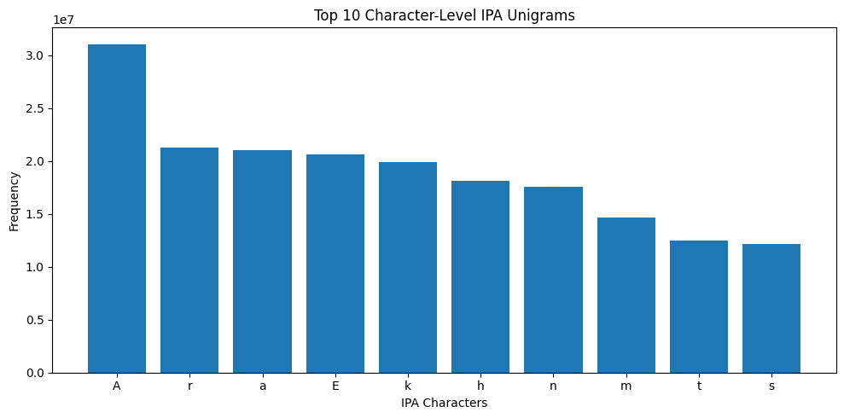
Figure 4.1 visually compares the frequencies of the ten most common IPA characters. The graph highlights the dominance of A, while the remaining characters show comparatively lower but still substantial frequencies.
4.2.2 Top Character-Level IPA Bigrams
Character-level bigrams represent two consecutive IPA characters and provide information about common phonetic transitions. Table 4.2 presents the ten most frequent bigrams identified in the complete corpus.

Table 4.2: Top 10 Character-Level IPA Bigrams
Rank | IPA Bigram | Frequency
1 | ẽ | 4,801,809
2 | ar | 3,686,158
3 | ̃ː | 3,376,142
4 | kE | 3,294,923
5 | An | 3,156,367
6 | Ar | 2,993,996
7 | Ah | 2,973,635
8 | hɛ | 2,784,213
9 | Ek | 2,755,670
10 | ɪs | 2,713,861

The bigram ẽ had the highest frequency, followed by ar, ̃ː, and kE. These frequently occurring sequences reflect common adjacent phonetic patterns in the corpus. Preserving such bigrams is important because they represent contextual information that cannot be captured through individual characters alone.

Figure 4.2: Top 10 Character-Level IPA Bigram Frequencies
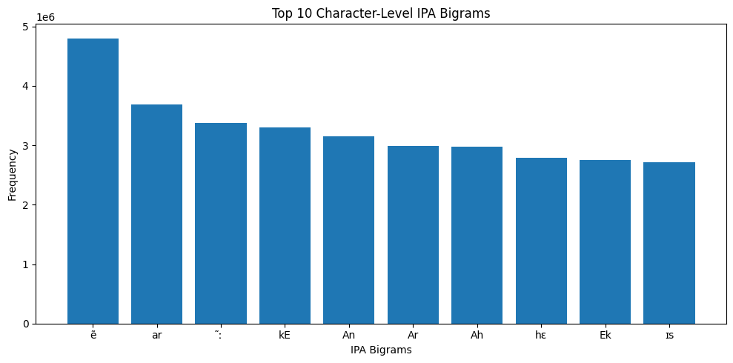
Figure 4.2 shows that the frequency of ẽ was noticeably higher than the other bigrams. However, the remaining top bigrams also occurred millions of times, demonstrating their importance in the phonetic structure of the corpus.
4.3 Evaluation of the Greedy Subset Selection Algorithm

This section presents the performance of the proposed greedy subset selection algorithm on the IPA-converted Urdu corpus. The algorithm was evaluated using six subset sizes, ranging from 0.1% to 20% of the complete corpus. Three evaluation metrics were used: Type Coverage, Token Probability Coverage, and KL Divergence. These metrics assess how effectively the selected subsets preserve the statistical characteristics of the original corpus.

4.3.1 Type Coverage
Type Coverage measures the proportion of unique character-level IPA units retained in the selected subset. Higher values indicate better preservation of the original corpus vocabulary.
Table 4.3: Character-Level Type Coverage of the Greedy Algorithm
Subset Size | Unigram Type Coverage | Bigram Type Coverage
greedy_0_1_percent | 1 | 1
greedy_1_percent | 1 | 1
greedy_5_percent | 1 | 1
greedy_10_percent | 1 | 1
greedy_15_percent | 1 | 1
greedy_20_percent | 1 | 1
Table 4.3 shows that both unigram and bigram type coverage remained 1.0 for all evaluated subset sizes. This indicates that every selected subset preserved all unique character-level IPA units present in the complete corpus. Even the smallest subset (0.1%) retained the complete set of unigram and bigram types, demonstrating the effectiveness of the greedy selection strategy in maintaining corpus diversity.
4.3.2 Token Probability Coverage
Token Probability Coverage evaluates how well the selected subset preserves the probability distribution of the original corpus.
Table 4.4: Character-Level Token Probability Coverage of the Greedy Algorithm

Subset Size | Unigram Token Probability Coverage | Bigram Token Probability Coverage
greedy_0_1_percent | 1 | 1
greedy_1_percent | 1 | 1
greedy_5_percent | 1 | 1
greedy_10_percent | 1 | 1
greedy_15_percent | 1 | 1
greedy_20_percent | 1 | 1

The results presented in Table 4.4 indicate that both unigram and bigram token probability coverage remained equal to 1.0 across all subset sizes. These findings suggest that the greedy algorithm successfully maintained the original frequency distribution of character-level IPA units. Consequently, the selected subsets accurately represent the statistical properties of the complete corpus.
4.3.3 KL Divergence Analysis
KL Divergence measures the difference between the probability distribution of the selected subset and that of the original corpus. Lower values indicate greater similarity.
Table 4.5: Character-Level KL Divergence of the Greedy Algorithm
Subset Size | Unigram KL Divergence | Bigram KL Divergence
greedy_0_1_percent | 0.00584 | 0.01805
greedy_1_percent | 0.00019 | 0.00094
greedy_5_percent | 0.00001 | 0.00015
greedy_10_percent | 0.00000 | 0.00006
greedy_15_percent | 0.00000 | 0.00004
greedy_20_percent | 0.00000 | 0.00003

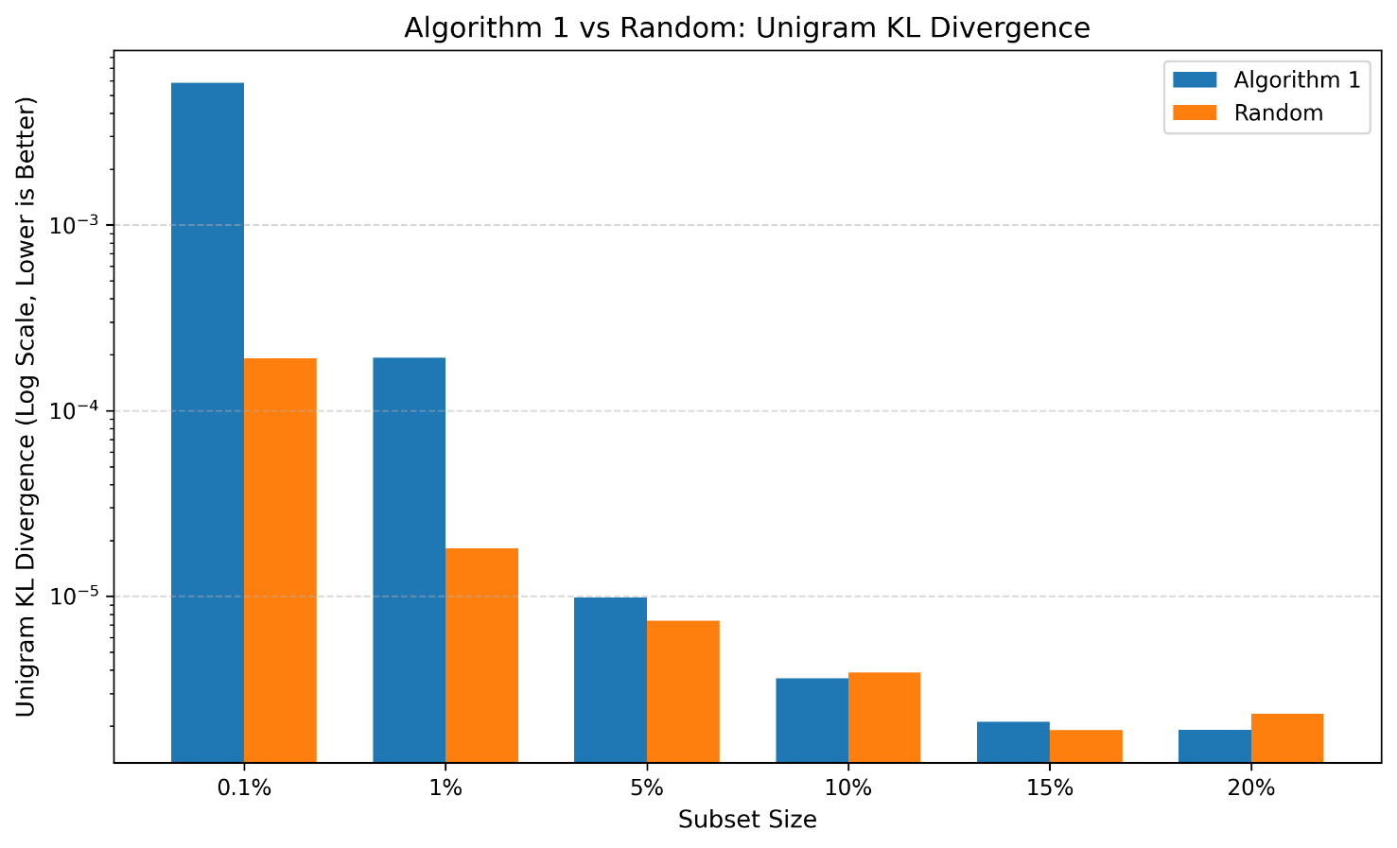
Figure 4.3: Unigram KL Divergence (ALG1_RANDOM_UNIGRAM_KL_BAR.png)
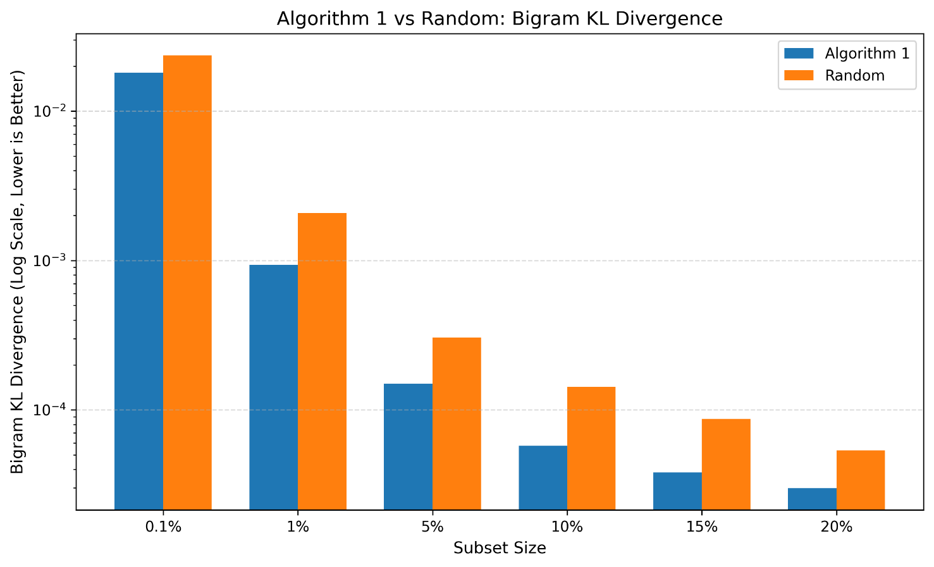

Figure 4.4: Bigram KL Divergence (ALG1_RANDOM_BIGRAM_KL_BAR.png)
Table 4.5 shows a consistent reduction in KL divergence as the subset size increased. For unigrams, the KL divergence decreased from 0.005837 for the 0.1% subset to 0.000002 for the 20% subset. A similar trend was observed for bigrams, where the divergence reduced from 0.018051 to 0.000030. These results indicate that larger subsets provide a closer approximation to the statistical distribution of the complete corpus.
Figures 4.3 and 4.4 further illustrate this trend. In both unigram and bigram analyses, the KL divergence decreases steadily with increasing subset size, demonstrating that the greedy algorithm produces increasingly representative subsets as more data are included.
Summary
Overall, the greedy subset selection algorithm preserved the statistical characteristics of the original corpus effectively. Complete type coverage and token probability coverage were maintained across all subset sizes, while KL divergence consistently decreased as the subset size increased. These results confirm that the proposed greedy algorithm is capable of generating representative subsets from the IPA-converted Urdu corpus.
4.4 Evaluation of the Random Sampling Method
This section presents the performance of the random sampling method for selecting representative subsets from the IPA-converted Urdu corpus. The same subset sizes (0.1%, 1%, 5%, 10%, 15%, and 20%) and evaluation metrics were used to ensure a fair comparison with the proposed greedy algorithm. The performance of the random sampling method was evaluated using Type Coverage, Token Probability Coverage, and KL Divergence.
4.4.1 Type Coverage
Type Coverage measures the proportion of unique character-level IPA unigrams and bigrams retained in the selected subsets. Higher values indicate better preservation of the diversity of the original corpus.
Subset Size | Unigram Type Coverage | Bigram Type Coverage
random_0_1_percent | 0.88462 | 0.65326
random_1_percent | 0.88462 | 0.80975
random_5_percent | 0.89744 | 0.899
random_10_percent | 0.9359 | 0.92836
random_15_percent | 0.94872 | 0.94627
random_20_percent | 0.97436 | 0.95567

Table 4.6: Character-Level Type Coverage of the Random Sampling Method
Table 4.6 presents the unigram and bigram type coverage achieved by the random sampling method for different subset sizes. The results show that type coverage generally increased as the subset size became larger. Smaller subsets retained fewer unique IPA units, whereas larger subsets preserved a greater proportion of the original corpus. This indicates that increasing the subset size improves the ability of random sampling to retain phonetic diversity.

4.4.2 Token Probability Coverage
Token Probability Coverage evaluates how effectively the selected subset preserves the frequency distribution of the original corpus.
Subset Size | Unigram Token Probability Coverage | Bigram Token Probability Coverage
random_0_1_percent | 1 | 0.999237
random_1_percent | 1 | 0.999937
random_5_percent | 1 | 0.999992
random_10_percent | 1 | 0.999996
random_15_percent | 1 | 0.999998
random_20_percent | 1 | 0.999999

Table 4.7: Character-Level Token Probability Coverage of the Random Sampling Method
The results in Table 4.7 indicate that unigram and bigram token probability coverage remained close to 1.0 for all subset sizes. This suggests that the overall frequency distribution of the original corpus was largely preserved even when the subsets were selected randomly. Only minor differences were observed among the evaluated subset sizes.
4.4.3 KL Divergence Analysis
KL Divergence measures the statistical difference between the probability distribution of the selected subset and that of the complete corpus. Lower KL divergence values indicate greater similarity between the selected subset and the original corpus.
Subset Size | Unigram KL Divergence | Bigram KL Divergence
random_0_1_percent | 0.000192 | 0.023639
random_1_percent | 1.82E-05 | 0.002079
random_5_percent | 7.41E-06 | 0.000304
random_10_percent | 3.90E-06 | 0.000142
random_15_percent | 1.90E-06 | 8.71E-05
random_20_percent | 2.33E-06 | 5.37E-05
Table 4.8: Character-Level KL Divergence of the Random Sampling Method
The results show that the KL divergence values decreased gradually with increasing subset size. The smallest subset exhibited the highest divergence from the original corpus, while the largest subset achieved the lowest divergence. This behaviour indicates that larger randomly selected subsets provide a better approximation of the statistical characteristics of the complete IPA-converted corpus.

Summary
Overall, the random sampling method preserved the statistical properties of the original corpus reasonably well. Larger subsets consistently achieved higher coverage and lower KL divergence than smaller subsets, demonstrating that subset size has a significant influence on the representativeness of randomly selected data. The performance of the random sampling method is compared with the proposed greedy algorithm in the following section.
4.5 Comparative Analysis of the Greedy Algorithm and Random Sampling
This section compares the performance of the proposed greedy subset selection algorithm with the random sampling method using the evaluation metrics discussed in the previous sections. The comparison is based on Type Coverage, Token Probability Coverage, and KL Divergence to evaluate the ability of both methods to preserve the statistical characteristics of the complete IPA-converted Urdu corpus.
4.5.1 Type Coverage Comparison
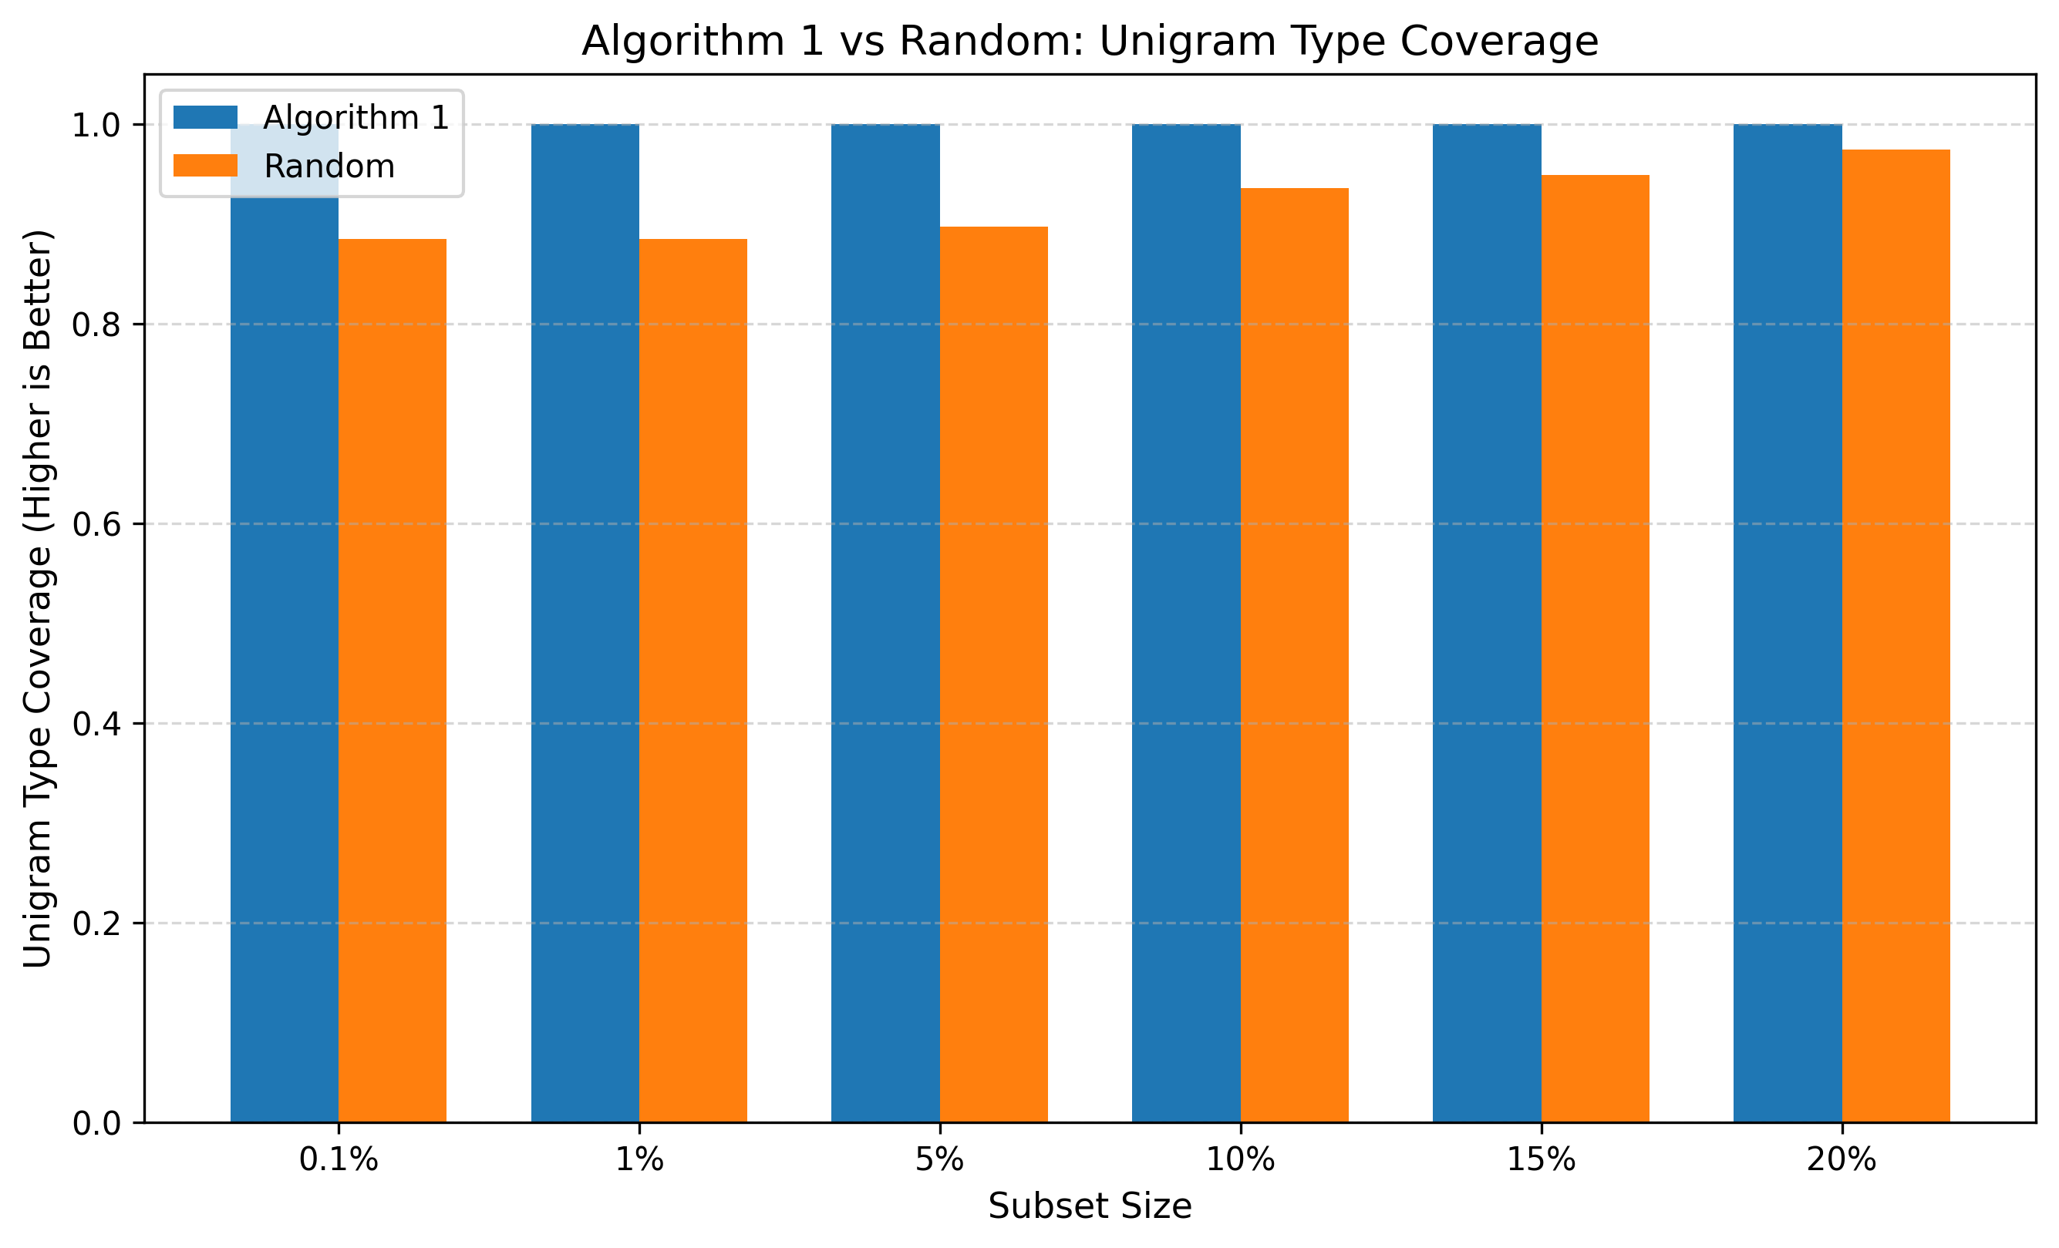
Figure 4.5: Comparison of Unigram Type Coverage between the Greedy Algorithm and Random Sampling
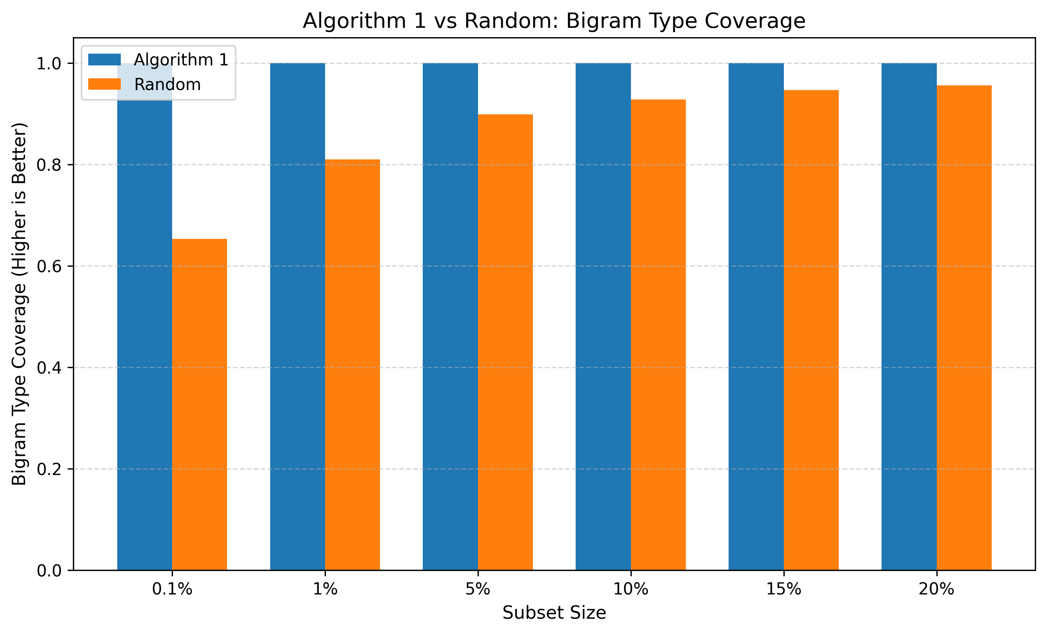
Figure 4.6: Comparison of Bigram Type Coverage between the Greedy Algorithm and Random Sampling
Figures 4.5 and 4.6 compare the unigram and bigram type coverage obtained using the greedy algorithm and random sampling. The results show that the greedy algorithm consistently achieved higher type coverage, particularly for smaller subset sizes. As the subset size increased, the difference between the two methods gradually decreased because both methods retained a larger proportion of the unique IPA units. These findings indicate that the greedy algorithm is more effective in preserving corpus diversity when only a small subset is selected.

4.5.2 Token Probability Coverage Comparison
Figure 4.7: Comparison of Unigram Token Probability Coverage between the Greedy Algorithm and Random Sampling
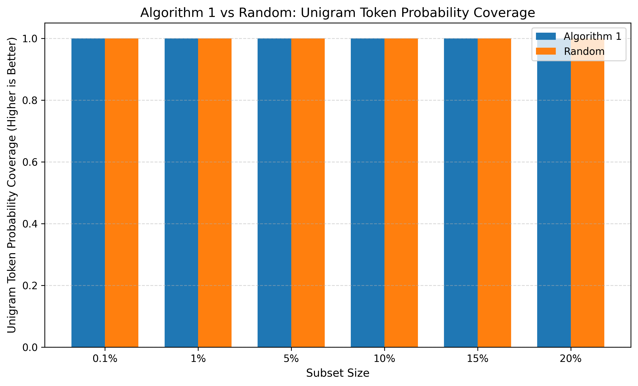
Figure 4.8: Comparison of Bigram Token Probability Coverage between the Greedy Algorithm and Random Sampling
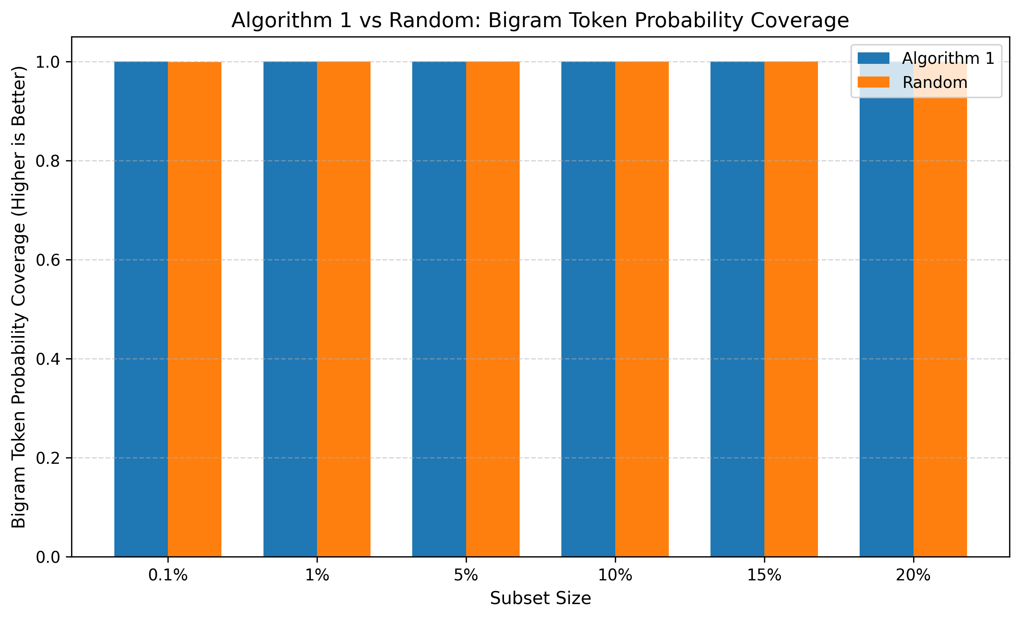
Figures 4.7 and 4.8 illustrate the comparison of token probability coverage for both methods. The results indicate that both approaches maintained token probability coverage values close to 1.0 across all subset sizes. This demonstrates that both methods were able to preserve the frequency distribution of the original corpus effectively. The differences between the two approaches were relatively small for this metric.
4.5.3 KL Divergence Comparison
Figure 4.9: Comparison of Unigram KL Divergence between the Greedy Algorithm and Random Sampling


Figure 4.10: Comparison of Bigram KL Divergence between the Greedy Algorithm and Random Sampling

Figures 4.9 and 4.10 present the comparison of KL divergence values obtained using the greedy algorithm and random sampling. Lower KL divergence indicates greater similarity between the selected subset and the original corpus. The results show that the divergence values decreased as the subset size increased for both methods. At larger subset sizes, the statistical distributions of both methods became increasingly similar to that of the complete corpus.

4.6 Discussion
The experimental results demonstrate that both the greedy algorithm and the random sampling method were capable of preserving the statistical characteristics of the IPA-converted Urdu corpus. The frequency analysis confirmed the presence of dominant unigram and bigram IPA units within the corpus, while the evaluation metrics showed that representative subsets could be generated using either approach.
The greedy algorithm consistently achieved high type coverage across all subset sizes and maintained the probability distribution of the original corpus. Similarly, the random sampling method preserved the corpus characteristics effectively, particularly for larger subsets. For both methods, KL divergence decreased as the subset size increased, indicating that larger subsets provide a closer approximation to the statistical distribution of the complete corpus.
Overall, the experimental findings suggest that preserving statistical characteristics depends not only on the subset selection method but also on the amount of data selected. Larger subsets generally produced more representative samples regardless of the selection strategy.

4.7 Chapter Summary
This chapter presented the experimental evaluation of the proposed subset selection framework. Initially, the statistical characteristics of the IPA-converted Urdu corpus were analysed using character-level unigram and bigram frequency distributions. Subsequently, the greedy algorithm and the random sampling method were evaluated using type coverage, token probability coverage, and KL divergence. Finally, a comparative analysis of both approaches was conducted to examine their effectiveness in preserving the statistical properties of the original corpus.
The experimental results demonstrate that representative subsets can successfully preserve the statistical characteristics of the complete IPA-converted Urdu corpus. Furthermore, increasing the subset size improves the representativeness of the selected subsets by reducing the statistical difference between the subset and the original corpus. These findings support the effectiveness of the proposed subset selection framework for Urdu speech corpus development.

CHAPTER 5
CONCLUSION AND FUTURE WORK
5.1 Conclusion
This research proposed two greedy-based algorithms for representative subset selection from a large Urdu speech corpus using character-level IPA unigram and bigram statistics. The primary objective was to reduce the amount of text required for speech corpus construction while preserving the statistical and phonetic characteristics of the original corpus.
Algorithm 1 employed a Lazy Greedy selection strategy to maximize IPA unigram and bigram coverage. The experimental results showed that the algorithm successfully achieved complete type coverage while maintaining low KL Divergence across different subset sizes. The selected subsets preserved almost the entire token probability distribution of the original corpus.
Algorithm 2 introduced a deficit-driven greedy strategy that selected sentences containing under-represented IPA units. Instead of maximizing only feature coverage, it gradually reduced the statistical difference between the selected subset and the complete corpus. The results demonstrated that corpus representativeness improved consistently as the subset size increased.

The proposed greedy-based approaches were also compared with random sampling. The comparison showed that the proposed methods consistently achieved better Bigram KL Divergence, indicating superior preservation of contextual phonetic information. Overall, the proposed algorithms generated representative subsets suitable for data-efficient Urdu speech corpus construction.

5.2 Research Contributions
The major contributions of this research are summarized as follows:
- Developed a representative subset selection framework for Urdu speech corpus construction using character-level IPA representation.
- Proposed a Lazy Greedy Algorithm for maximizing unigram and bigram coverage.
- Proposed a Deficit-Driven Greedy Algorithm for distribution-aware subset selection.
- Evaluated representative subsets using Type Coverage, Token Probability Coverage, and KL Divergence.
- Compared the proposed methods with random sampling using multiple subset sizes ranging from 0.1% to 20%.
- Demonstrated that greedy-based informed selection preserves contextual phonetic information more effectively than random sampling.
5.3 Limitations
This research has several limitations.
- The experiments were conducted only on a single Urdu IPA corpus.
- Evaluation was limited to character-level unigram and bigram statistics.
- Higher-order n-grams and linguistic features such as words, syllables, or phonemes were not considered.
- Algorithm 2 required substantially higher computational resources because exact score computation was performed during every selection iteration.
- The selected subsets were evaluated statistically and were not validated using an actual speech recognition or speech synthesis system.
5.4 Future Work
Several directions may be explored in future research.
- Extend the proposed framework to multilingual and low-resource speech corpora.
- Incorporate trigram or higher-order n-gram information during subset selection.
- Integrate linguistic and phonetic features beyond character-level IPA representation.
- Develop more computationally efficient approximation methods for deficit-driven greedy selection.
- Evaluate the selected subsets using downstream speech recognition and speech synthesis systems to measure practical performance improvements.

References
- Y. Yang et al., “Enhancing low-resource ASR through versatile TTS: Bridging the data gap,” in Proc. International Conference on Speech Technology, 2024.
- K. Seki, S. Takamichi, T. Saeki, and H. Saruwatari, “Text-to-speech synthesis from dark data with evaluation-in-the-loop data selection,” in Proc. Interspeech, 2023.
- A. Maekawa, S. Kosugi, K. Funakoshi, and M. Okumura,, “DiLM: Distilling dataset into language model for text-level dataset distillation,” arXiv preprint, 2024.
- A. Gunduz, K. A. Yuksel, K. Darwish, G. Javadi, F. Minazzi, N. Sobieski, and S. Bratière, “An automated end-to-end open-source software for high-quality text-tospeech dataset generation,” arXiv preprint, 2024.
- S. Kothawade, A. Mekala, C. S. D., M. Kothyari, R. Iyer, G. Ramakrishnan, and P. Jyothi,, “DITTO: Data-efficient and fair targeted subset selection for ASR accent adaptation,” in Proc. International Conference on Speech Processing, 2023.
- Samuele Cornell, Jordan Darefsky, Zhiyao Duan, Shinji Watanabe1, “Generating data with text-to-speech and large-language models for conversational speech recognition,” in Proc. IEEE Automatic Speech Recognition and Understanding Workshop (ASRU), 2023.
- A. A. Raza et al., “Design and development of phonetically rich Urdu speech corpus,” in Proc. International Conference on Language Resources and Evaluation (LREC), 2009.
- Kai-Zhan. Lee and Erica. Cooper, Julia Hirschberg “A comparison of speaker-based and utterance-based data selection for text-to-speech synthesis,” in Proc. Interspeech, 2018.
- P. O. Gallegos et al., “An unsupervised method to select a speaker subset from large multi-speaker speech synthesis datasets,” in Proc. Interspeech, 2020.
- S. Taubert et al., “A comparison of text selection algorithms for sequence-to-sequence neural TTS,” in Proc. ICSPCC, 2022.
- O. Sener and S. Savarese, “Active learning for convolutional neural networks: A coreset approach,” arXiv preprint arXiv:1708.00489, 2017.
- S. Khan et al., “Overcoming linguistic barriers: Developing advanced Urdu text-tospeech systems,” in Proc. International Conference on Speech Technology, 2024.
- Srihari Bandarupalli, Bhavana Akkiraju, Charan Devarakonda, Vamsiraghusimha
Narsinga1 , Anil Kumar Vuppala, “Efficient ASR for low-resource languages,” arXiv preprint, 2025.
- K. Seki, S. Takamichi, T. Saeki, and H. Saruwatari, “Active learning for text-to-speech synthesis with informative sample collection,” in Proc. Interspeech, 2021.
- D. Becker, A Study in Urdu Corpus Construction. Berlin, Germany: Academic Press, 2002.
- S. Arif, A. J. Khan, M. Abbas, A. A. Raza, and A. Athar, “WER We Stand:
Benchmarking Urdu ASR Models,” in Proc. 31st Int. Conf. Computational Linguistics (COLING), Abu Dhabi, UAE, 2025, pp. 5952–5961.
- A. H. Azeemi, I. A. Qazi, and A. A. Raza,, “A survey on data selection for efficient speech processing,” IEEE Access, 2025.
- K. Seki et al., “Diversity-based core-set selection for text-to-speech with linguistic and acoustic features,” in Proc. Interspeech, 2022.
- S. Rangappa et al., “Speech data selection for efficient ASR fine-tuning using domain classifier and pseudo-label filtering,” in Proc. IEEE ASRU, 2023.
- Y. Zheng et al., “Unsupervised active learning: Optimizing labeling cost-effectiveness for automatic speech recognition,” in Proc. IEEE ICASSP, 2024.
- D. Das and V. Khetan,, “DEFT-UCS: Data efficient fine-tuning for pre-trained language models via unsupervised core-set selection for text-editing,” arXiv preprint, 2024.
- F. Naseem, M. Sajid, F. Adeeba, S. Rauf, A. Mustafa, and S. Hussain,, “Developing high-quality TTS for Punjabi and Urdu against MMS model,” Technical Report (PDF), 2024.
- K. Seki, S. Takamichi, T. Saeki, and H. Saruwatari,“TTSOps: A closed-loop corpus optimization framework for training multi-speaker TTS models from dark data,” IEEE/ACM Transactions on Audio, Speech, and Language Processing, 2022.
- S. Hussain, P. Neekhara, X. Yang, E. Casanova, S. Ghosh, R. Fejgin, R. Langman, M.
Desta, L. Tavabi, and J. Li,“ALIGN2SPEAK: Improving TTS for low resource languages via ASR-guided online preference optimization,” arXiv preprint arXiv:2509.21718v1 [cs], 2025.

Footnotes
¹[Add footnotes, if any, on their own page following references. For APA formatting requirements, it’s easy to just type your own footnote references and notes. To format a footnote reference, select the number and then, on the Home tab, in the Styles gallery, click Footnote Reference. The body of a footnote, such as this example, uses the Normal text style. (Note: If you delete this sample footnote, don’t forget to delete its in-text reference as well. That’s at the end of the sample Heading 2 paragraph on the first page of body content in this template.)]

Table 1
[Table Title]
Column Head | Column Head | Column Head | Column Head | Column Head
Row Head | 123 | 123 | 123 | 123
Row Head | 456 | 456 | 456 | 456
Row Head | 789 | 789 | 789 | 789
Row Head | 123 | 123 | 123 | 123
Row Head | 456 | 456 | 456 | 456
Row Head | 789 | 789 | 789 | 789
Note: [Place all tables in their own section, following references (and, if applicable, footnotes). Start a new page for each table, include a table number and table title for each, as shown on this page. All explanatory text appears in a table note that follows the table, such as this one. Use the Table/Figure style, available on the Home tab, in the Styles gallery, to get the spacing between table and note. Tables in APA format can use single or 1.5 line spacing. Include a heading for every row and column, even if the content seems obvious. A default table style has been setup for this template that fits APA guidelines. To insert a table, on the Insert tab, click Table.]
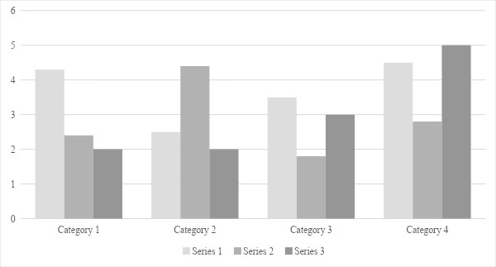
Figure 1. [Figure Title]
[Include all figures in their own section, following references (and footnotes and tables, if applicable). Include a numbered caption for each figure. Use the Table/Figure style for easy spacing between figure and caption.]

Appendix

For any supplementary material that supervisor considers important and should be included. Examples include FORMS, CODING etc.

PLAGIARISM VERIFICATION (for Final Submission)
(Note: This form is filled at the final submission of Thesis/Research Project Reports for graduation.)

Title of Research Thesis:

Total Pages: __________
Student Name :

Registration ID :

Supervisor:
Program:

Faculty:

This is to report that the above document was scanned for similarity detection and has been submitted in turnitin repository. Process and outcome is given below:

Software used: Turnitin Date:
Similarity Index:

Total word count:

Digital Receipt No.:

File Name:

________________________

Signature and Stamp of the Office of Research & Project

PLAGIARISM REPORT

The Plagiarism Report issued shall be attached here

